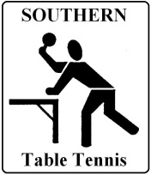
Southern Table Tennis
Polo Top ‘Order Form’

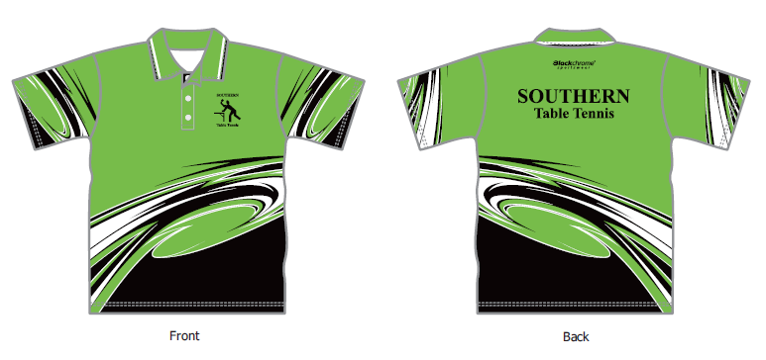
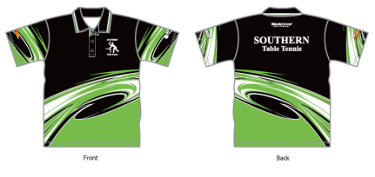

Green Variation
Black Variation
S45 00 each

Name:
Mobile: Email:
Quantity: Adult or Junior: Size: (use size charts overleaf)
Which Variation (Black or Green):

Note: Southern players / social members can place orders through the Club canteen. Once an order is placed, stock takes between 4 to 6 weeks to arrive. In some cases small quantities of popular sizes are maintained for immediate purchase. Anyone else seeking to make a purchase should contact admin@southerntabletennis.org.au

Payment: The cost of polo tops for pick up from the Southern Table Tennis Club canteen is $45.00 each. Payment can be made in cash at the canteen or can be made online using the bank transfer.

Southern Table Tennis Inc. BSB: 805-022 Account: 02204430
Payment: Date Paid: ……/……/20……. Receipt No: …………………….. Amount Paid: $

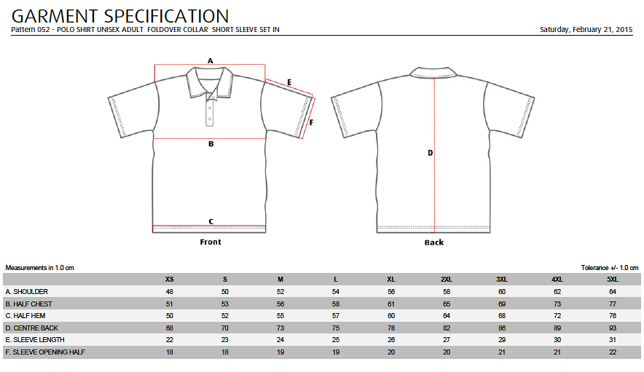
Adult Sizing:

Junior Sizing:
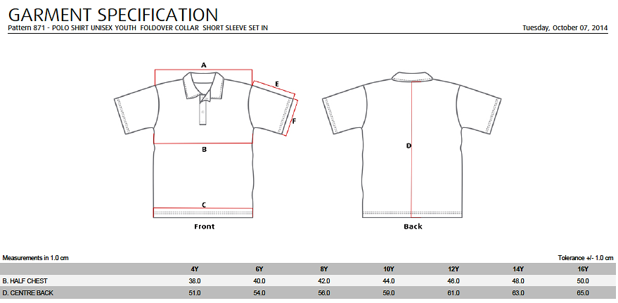

Return this form by email to the Secretary, Southern Table Tennis at admin@southerntabletennis.org.au
Otherwise, lodge the completed form at the Southern Table Tennis venue canteen.

