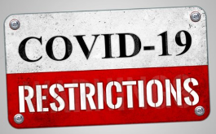
STT Covid-19 Sharing of Responsibilities
As at 15 April 2022

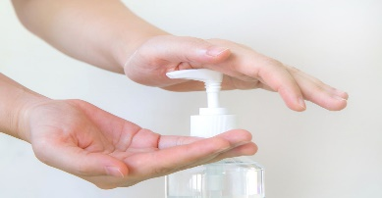
Responsibilities – Southern Table Tennis:
- Maintain hygiene of the venue
- Provide hand sanitizer for player use
- Venue layout encourages social distancing off court
- Ensure the current Covid Safe Plan is implemented

Responsibilities – Player:
- Do not enter the venue if sick or possessing cold of flu symptoms
- Keep personal hand towels in your bag (bags can be taken out on court)
- Avoid putting your hands on the table and do not use your personal towel to clean the table. Micro fibre cleaning cloths are available at the canteen.
- Wash your hands / use hand sanitizer on entry to the stadium, during the session, before and after using scorers, and on departure.
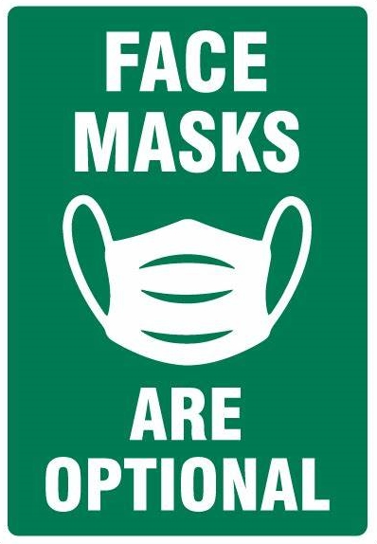
- Acknowledge you opponent at the end of the match, but no shaking of hands.

Southern Executive Committee

