Players with a "Southern connection" who performed well at the recent Australian Veterans Table Tennis Championships held in Hobart from the 18th to 25th October 2014
Steven Hart - No. 9 in the Order of Merit for the Over 30 Men
- Silver Medallist in the Over 30 Men's Teams
Paul Glassenbury - No. 10 in the Order of Merit for the Over 30 Men
- Silver Medallist in the Over 30 Men's Teams
- Silver Medallist in the Over 30 Men's Doubles with Paul Langley (SA)
George Abdilla - No. 6 in the Order of Merit for the Over 60 Men
- Bronze Medallist in the Over 60 Men's Singles
Cynthia Langley - No.3 in the Order of Merit for the Over70 Women - Gold Medallist in the Over 70 Women's Teams
- Silver Medallist in the Over 65 Women's Doubles with T. Yamamoto (JPN)
- Bronze Medallist in the Over 65 Mixed Doubles with Inh Le (NSW)
- Bronze Medallist in the Over 70 Women's Single
- Gold Medallist in the Over 70 Women's Doubles with Betty Bird (SA)
Paul Langley - No. 1 in the Order of Merit for the Over40 Men
-Winner of the Table Tennis World.com.au Award (Best Player )for Over 40 Men
- Gold Medallist in the Over 40 Men's Teams
- Bronze Medallist in the Over 30 Men's Singles
- Silver Medallist in the Over 30 Men's Doubles with Paul Glassenbury (SA)
- Gold Medallist in the Over 40 Men's Singles
- Gold Medallist in the Over 40 Men's Doubles with Sharad Pandit (SA)
- Silver Medallist in the Over 40 Mixed Doubles with Claire Langley
Claire Langley - Silver Medallist in the Over 40 Mixed Doubles with Paul Langley
Scott Houston - No. 1 in the Order of Merit for the Over 30 Men
- Winner of the Table Tennis World.com.au Award (Best Player) for Over30
Men
- Silver Medallist in the Over30 Men's Teams
- Silver Medallist in the Over 30 Men's Singles
- Gold Medallist in the Over 30 Men's Doubles with An Phan (SA)
- Gold Medallist in the Over 30 Mixed Doubles with Wei Deng (NSW)
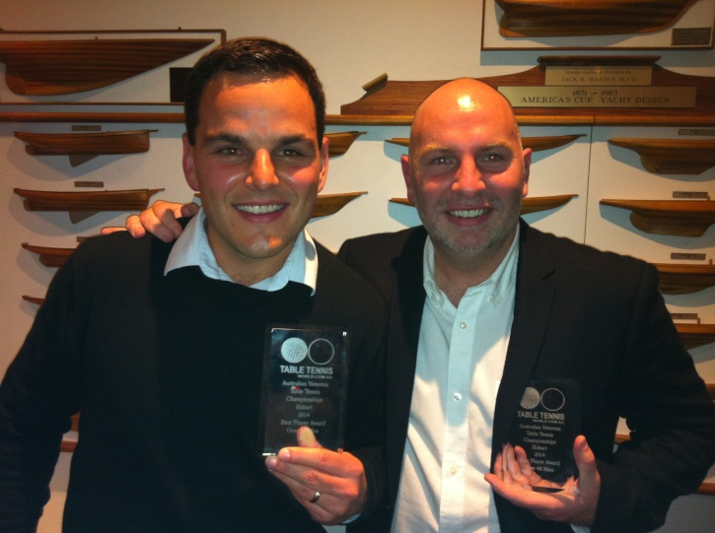
Scott Houston and Paul Langley with their Table Tennis World.com.au Awards

